**“ONLINE VOTING SYSTEM”**

***A***

***Project Report***

*submitted in partial fulfillment of the*

*requirements for the award of the degree of*

**BACHELOR OF TECHNOLOGY**

**in**

**COMPUTER SCIENCE & ENGINEERING**

**With Specialization in**

**Business Analytics and Optimization**

**by**

|  |  |
| --- | --- |
| **Name** | **Roll No.** |
| **Utkarsh Sharma** | **R103219028** |
| **Luxmi Rana** | **R103219010** |
| **Shivani Saran** | **R103219018** |
| **Chirag Raghuvanshi** | **R1032119027** |

***under the guidance of***

**Bikram Pratim Bhuyan**

upes-new-logo

**Department of Informatics**

**School of Computer Science**

**University of Petroleum & Energy Studies**

**Bidholi, Via Prem Nagar, Dehradun, UK**

**December – 2019**

upes-new-logo

**CANDIDATE’S DECLARATION**

We hereby certify that the project work entitled **“ Online Voting System”** in partial fulfilment of the requirements for the award of the Degree of BACHELOR OF TECHNOLOGY in COMPUTER SCIENCE AND ENGINEERING with specialization in Business Analytics and Optimisation and submitted to the Department of Informatics at School of Computer Science, University of Petroleum & Energy Studies, Dehradun, is an authentic record of our work carried out during a period from **February**, **2022** to **May**, **2022** under the supervision of **Bikram Pratim Bhuyan**.

The matter presented in this project has not been submitted by us for the award of any other degree of this or any other University.

|  |  |
| --- | --- |
| **Utkarsh Sharma** | **R103219028** |
| **Luxmi Rana** | **R103219010** |
| **Shivani Saran** | **R103219018** |
| **Chirag Raghuvanshi** | **R1032119027** |

This is to certify that the above statement made by the candidate is correct to the best of my knowledge.

Date: 12/05/2022 **Bikram Pratim Bhuyan**

Project Guide

**Dr. Thipendra Pal Singh**

**Professor and H.O.D**

Department of Informatics

School of Computer Science

University of Petroleum & Energy Studies

Dehradun – 248 001 (Uttarakhand)

**ACKNOWLEDGEMENT**

We wish to express our deep gratitude to our guide **Bikram Pratim Bhuran**, for all advice, encouragement and constant support he has given us through out our project work. This work would not have been possible without his support and valuable suggestions.

We sincerely thank to our respected Head of the Department, **Dr. Thipendra Pal Singh,**, for his great support in doing our minor project in **Area (like Network, Big data etc.)** at **SoCS**.

We are also grateful to **Dr. Manish Prateek, Dean SoCS**, for giving us the necessary facilities to carry out our project work successfully.

We would like to thank all our friends for their help and constructive criticism during our project work. Finally we have no words to express our sincere gratitude to our **parents** who have shown us this world and for every support they have given us.

|  |  |  |  |  |
| --- | --- | --- | --- | --- |
| **Name** | **Chirag** | **Luxmi** | **Shivani** | **Utkarsh** |
| **Roll No.** | **R103219027** | **R103219010** | **R103219018** | **R103219028** |

**ABSTRACT**

Our paper deals with online voting system that facilitates user(voter), candidate and administrator (who will be in charge and will verify all the user and information) to participate in online voting. our online voting system is highly secured, and it has a simple and interactive user interface. The proposed online portal is secured and have unique security feature such as unique id generation that adds another layer of security (except login id and password) and gives admin the ability to verify the user information and to decide whether he is eligible to vote or not. It also creates and manages voting and an election detail as all the users must login by user name and password and click on candidates to register vote. Our system is also equipped with a chat bot that works as a support or guide to the voters, this helps the users in the voting process.

**TABLE OF CONTENTS**

**1 Introduction 6**

**2 Related Work 6**

**(**List pros and corn of various algorithm studied in the project**)**

**3 Problem Statement 7**

**4 Objective 8**

**5 Design 9**

(Include Methodology )

(Define the Algorithm of the project)

**6 Implementation**

6.1 Output Screen 15

6.2 Result Analysis 19

**7 Conclusion and Future Scope 20**

**References 21**

**INTRODUCTION**

Elections enable every adult citizen of the country to participate in the process of government formation. we must have observed that elections are held in our country frequently. These include elections to elect members of the Lok Sabha, Rajya Sabha, State Legislative Assemblies (Vidhan Sabhas) Legislative Councils (Vidhan Parishad) and of, President and Vice-President of India. Elections are also held for local bodies such as municipalities, municipal corporations and Panchayati Raj justifications. Election is a complex exercise. It involves schedules rules and machinery.

With the advent of technology and Internet in our day to day life, we were able to offer advanced voting system to voters both in the country and outside through our online voting system[3]. We wish to propose an online voting system. Online voting is accessible across a variety of devices such as smartphones, tablets, and computers, making the entire voting process as simple as a click of a button or a tap on a screen. This also means the election can be accessed from anywhere in the world.Online voting can handle multiple modalities,and provide better scalability for large elections [4].Gone are the days you spend an entire meeting trying to pick a date when everyone is in town for the election. For example, if members are on vacation, they can simply log into the software and vote while lounging on the beach. This is also extremely beneficial for larger organizations with members living in different parts of the country. It avoids the burden of having to locate and rent out multiple polling sites or pay for a large number of mail ballots. All members can cast their ballot from the comfort of their home during the voting hours.

Advantages

Fast and easy way of conducting Election.

Voters can view background of each Candidate.

Candidate can present themselves against voters.

Admin can verify the documents and details of Candidate.

System Generated Unique ID and Password gives more Secure Logins.

Result will be out after 2 Hrs of Election.

Disadvantages

Chances of hacking candidate or voters account.

Every voter does not have pc or net connection, so voters can even go in polling booth and vote online there.

**Problem Statement**

The voting/polling process by registered voters is very cumbersome. So many cases of missing data in the voter registration files have been reported. There are also scenarios where unregistered voters flock in the polling centers as "Dead Voters" to participate in the voting process. The voters can vote from anywhere around the globe, they don't need to travel back during election time in case they are abroad using online voting system.

**Objective**

Purpose of the Project

Online voting tools and online election voting systems help you make important decisions by gathering the input of your group in a way that’s systematic and verifiable.

It’s a good idea to use an online voting system to:

Elect your leadership

Gather anonymous feedback from your employees.

Vote on yearly budgets.

Alter your operational procedures and by laws

The main purposes of OVS include:

Provision of improved voting services to the voters through fast, timelyand convenient voting.

Reduction of the costs incurred by the Kenyan Electoral Commission during voting time in paying the very many clerks employed for the sake ofthe success of the manual system.

Check to ensure that the members who are registered are the only ones tovote. Cases of "Dead People" voting are also minimized.

Online voting system (OVS) will require being very precise or cost cuttingto produce an effective election management.

Therefore crucial points that this (OVS) emphasizes on are listed below.

Require less number of staff during the election.

This system is a lot easier to independently moderate the elections and subsequently reinforce its transparency and fairness.

Less capital, less effort, and less labor intensive, as the primary cost

and effort will focus primarily on creating, managing, and running a

secure online portal. Increased number of voters as individual will find it easier and more

convenient to vote, especially those abroad.

**Design**

**Flow chart**

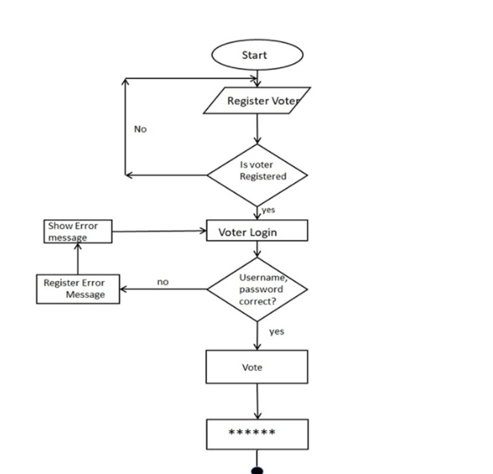

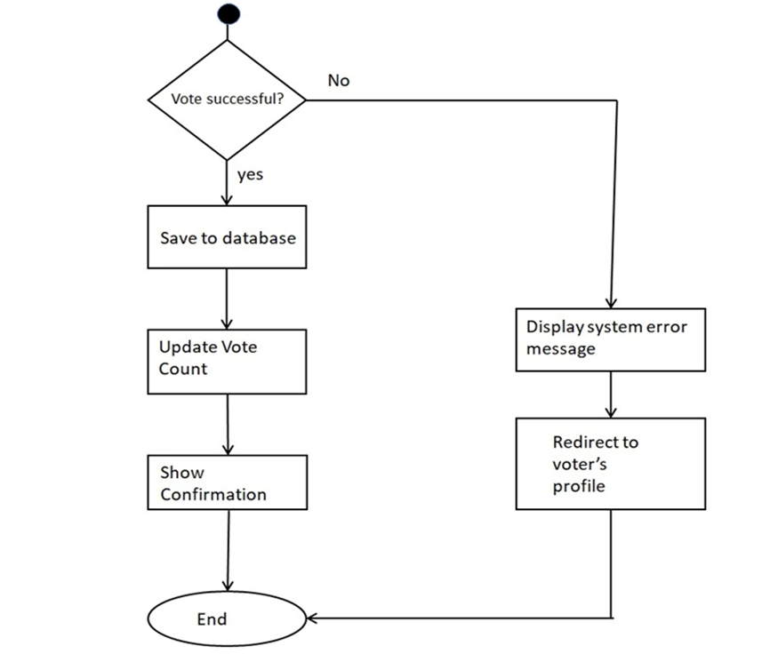

**Methodology**

* With the "ONLINE VOTING SYSTEM", a voter can use his/her voting right online without any difficulty.
* He/she has to register as a voter first before being authorized to vote. The registration should be done prior to the voting date to enable data update in the database.
* However, not just anybody can vote. For one to participate in the elections, he/she must have the requirements. For instance, he/she must be a registered citizen i.e. must be 18 and above years old.
* As already stated, the project ‘Online Voting' provides means for fast and convenient voting and access to this system is limited only to registered voters.

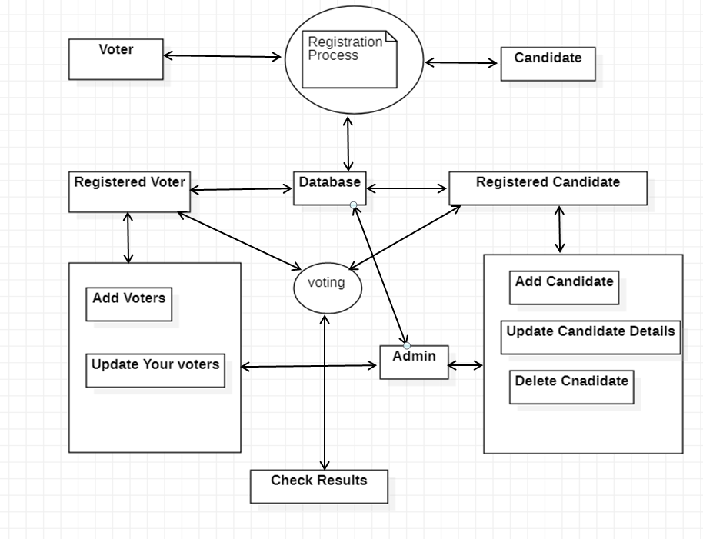

ER diagram

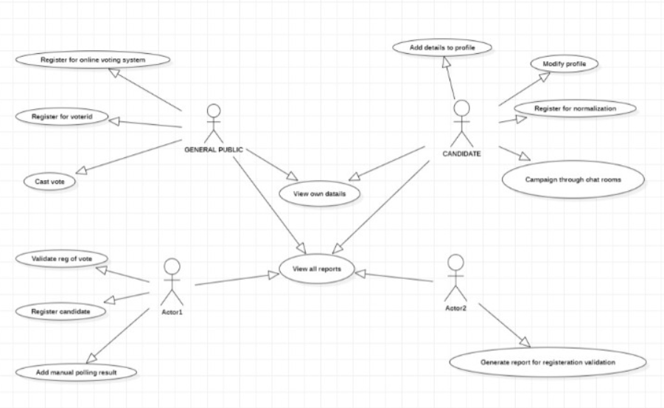

Block Diagram

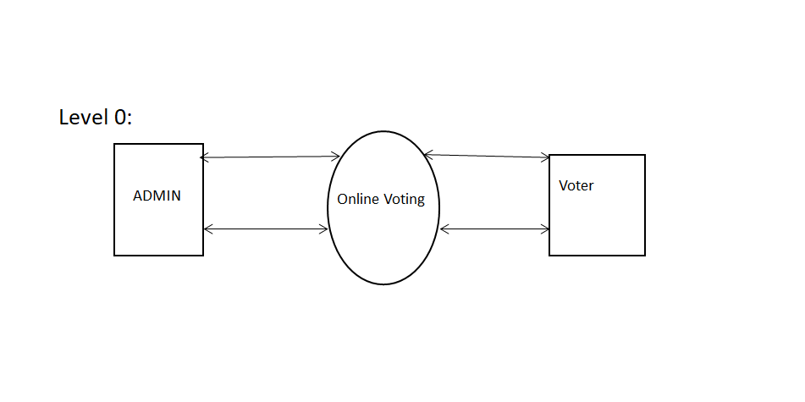 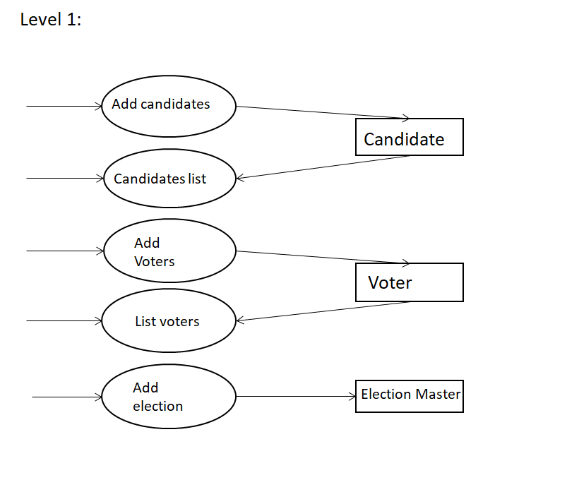

Data flow Diagram

**Experimentation**

**Output Screen**

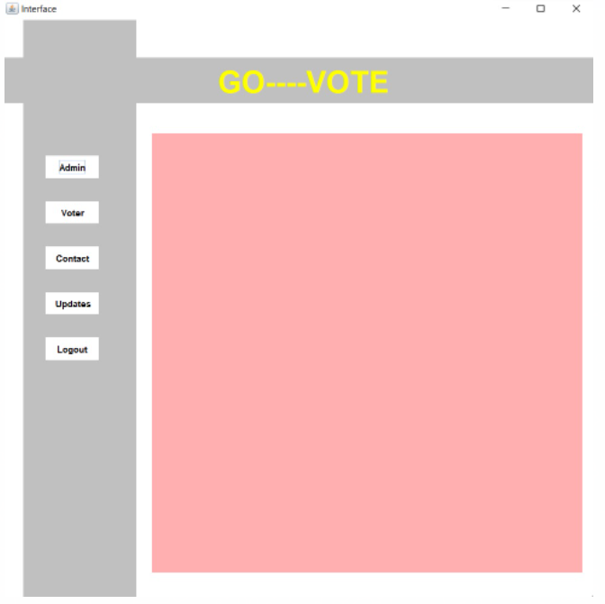

**Admin :-**

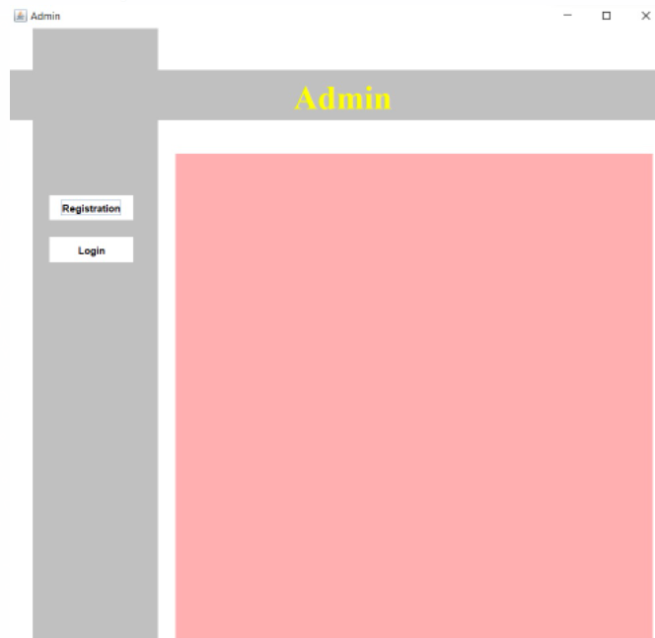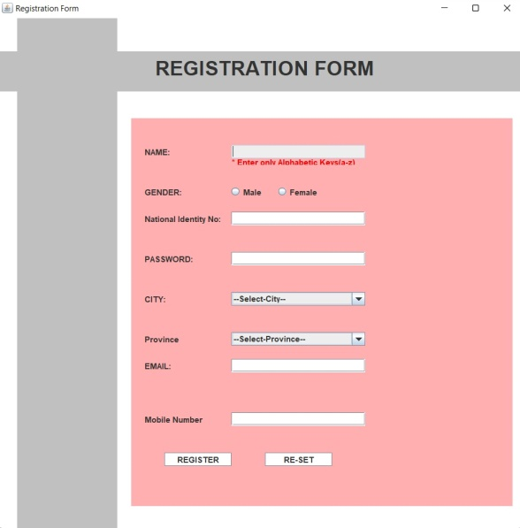

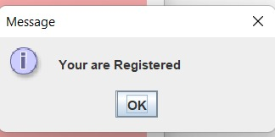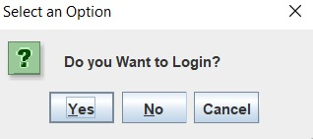

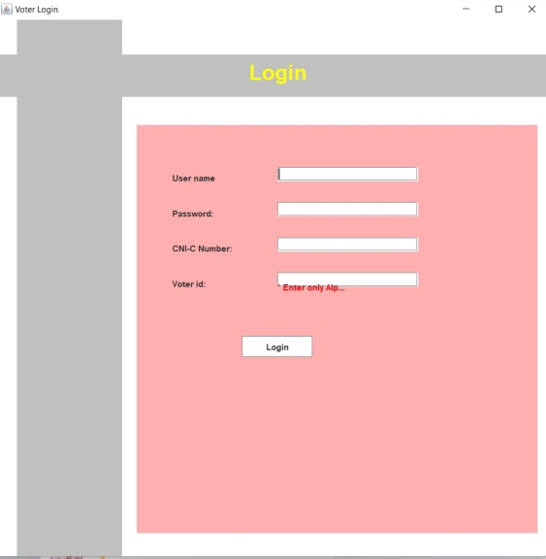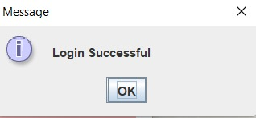

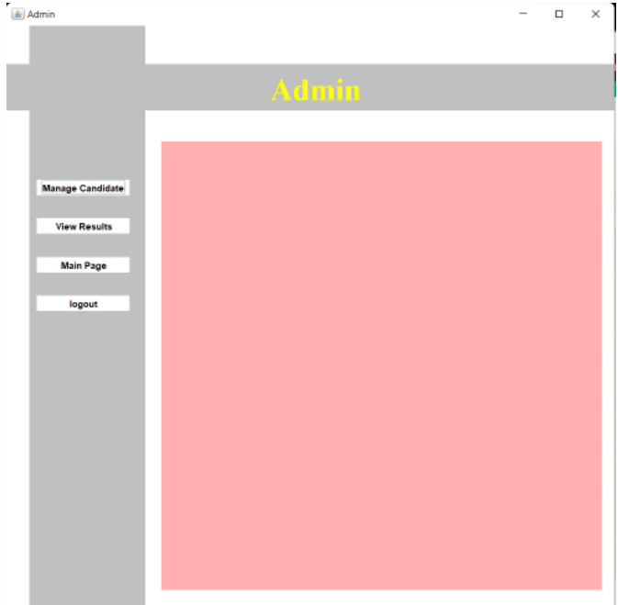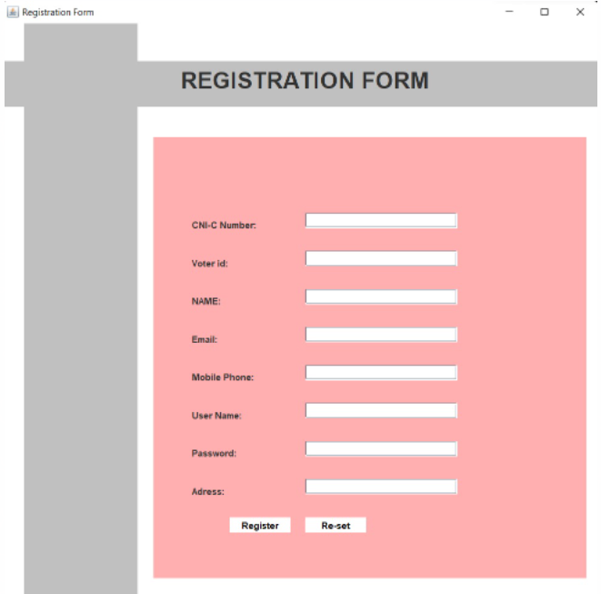

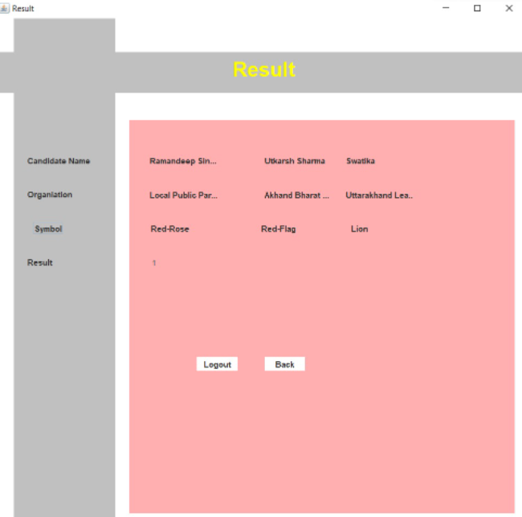

**VOTER**

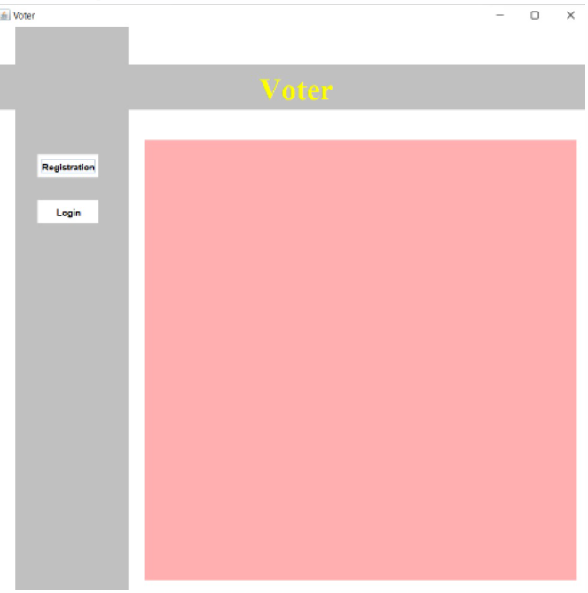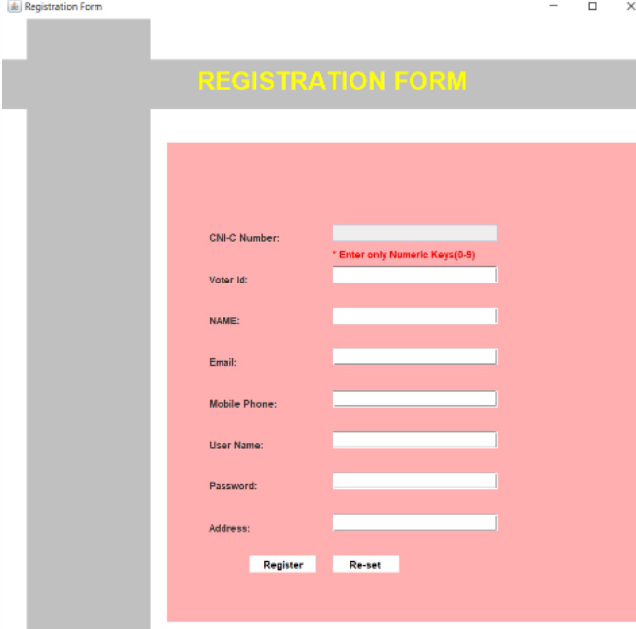

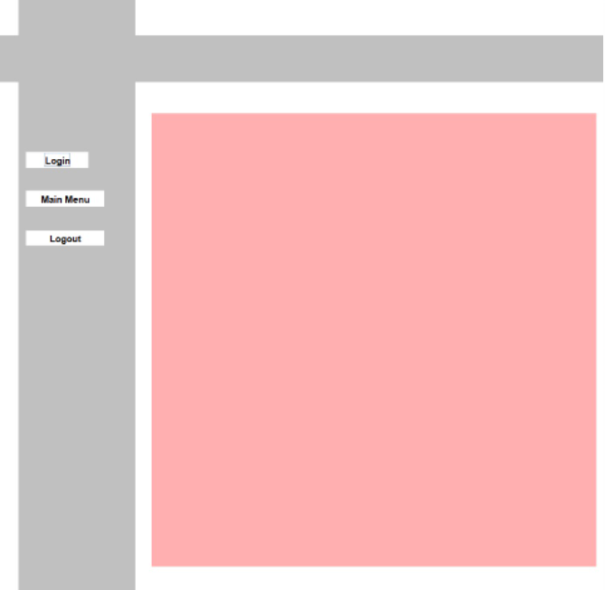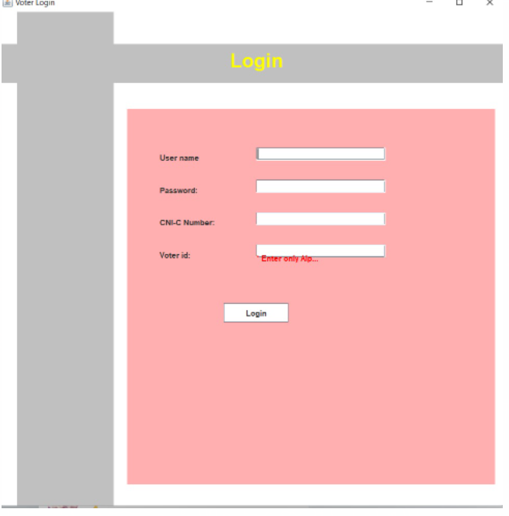

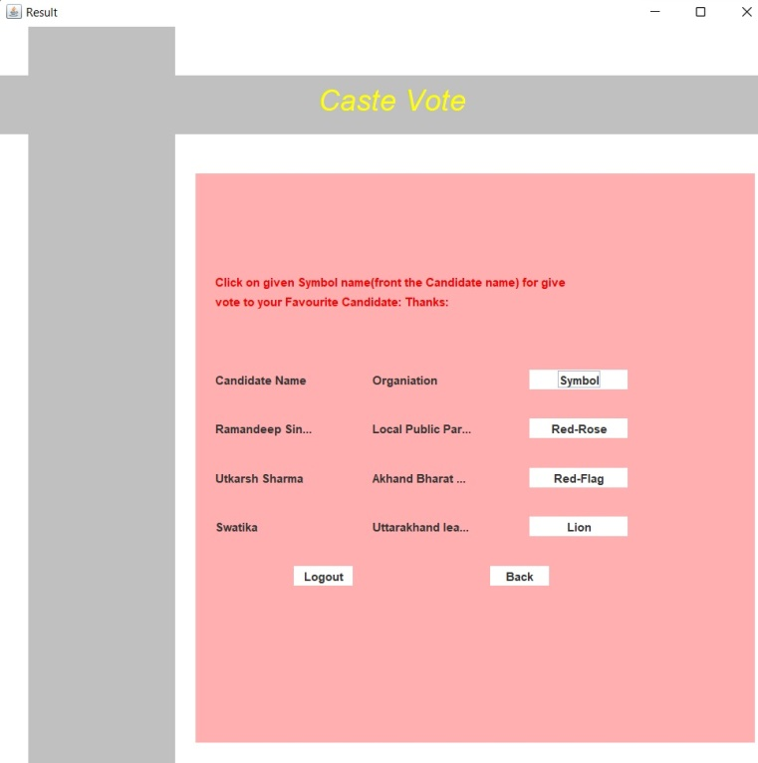

**UPDATES**

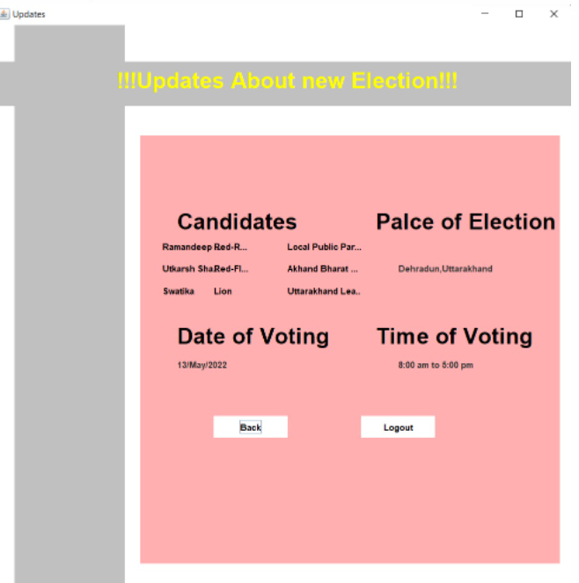

**CONTACT US**

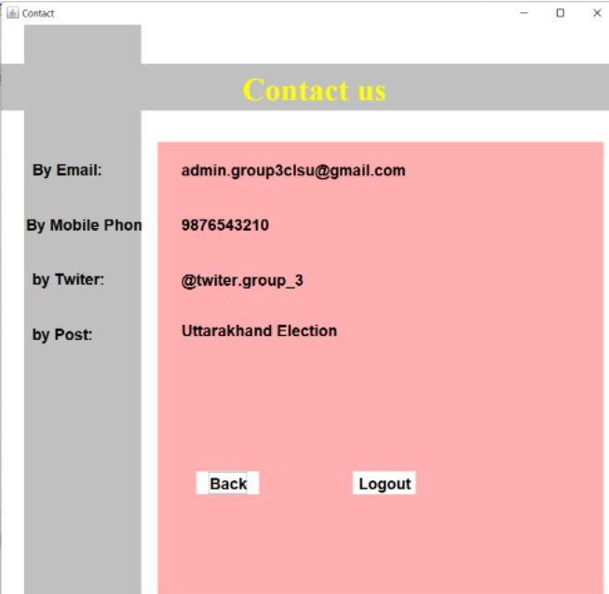

**Result Analysis**

* After running a vote, most online voting software will make it easy to see who or what won out across all the options. Detailed, custom reports are important to many organizations.
* These show trends like vote turnout, broken down by department, demographics, or region are helpful for understanding the results of your votes and elections at a deeper level.

**Conclusion and Future Scope**

Online Voting Systems have many advantages over the traditional voting system. Some of these advantages are less cost, faster generation results, easy accessibility, accuracy, and low risk of human and mechanical errors. It is very difficult to develop online voting system which can allow security and privacy on the high level. Future development focused to design a system which can be easy to use and will provide security and privacy of votes on acceptable level by proper authentication and processing section.. It is easy to use and it is less time consuming. It is very easy to debug.

1. Increasing number of voters as individuals will find it easier and more convenient to vote.
2. Less effort and less labor intensive, as the primary cost and focus primary on creating, managing, and running a secure web voting portal.
3. The system can be used anytime and from anywhere by the Voters.
4. No one can cast votes on behalf of others and multiple times.
5. Saves time and reduces human intervention.
6. The system is flexible and secured to be used.
7. Unique Identification of voter through Aadhar number.
8. Improves voting with friendly Interface.
9. No fraud vote can be submitted.

**Project Code**

import java.awt.Color;

import java.awt.Font;

import java.awt.Graphics;

import java.awt.Panel;

import java.awt.event.ActionEvent;

import java.awt.event.ActionListener;

import java.io.FileWriter;

import javax.swing.ButtonGroup;

import javax.swing.JButton;

import javax.swing.JComboBox;

import javax.swing.JFrame;

import javax.swing.JLabel;

import javax.swing.JOptionPane;

import javax.swing.JPasswordField;

import javax.swing.JRadioButton;

import javax.swing.JTextField;

public class MainPage implements ActionListener {

JFrame jf,j,vf,fb,fc,iaf,ivf,fu,fcc,Fcl;

JLabel l4,rl3,lr3,fls,cc,ce,cp,ifv,cpp,cee,ffu,ff,ft,ffl,tfl,ifa,lc,lc1,lc2,lc3,lc4,lc5,lc6,lcp,lcp1,

lcd,lcd1,lct,lct1,vtt,vtt1,lcs1,lcs2,lcs3,lcs,c,nc,idc,idv,ec,mc,uc,pcc,cac,sc,Lcg,cLv,nicv,vid,

ncv,mce,mcn,mcun,mcpn,mcan;

JButton vla1,b1,b2,b3,ja,ja1,kb3,kb4,kb5,lb6,vr,vl,gv,vlo,ac,ar,al,vp,vla,cb,cb1,lb0,fub,fub1,cbr,cbb,fvlb,fvLb;

JTextField tf,ncf,idcf,idvf,ecf,mcf,ucf,adc,cacp,sc1,nicvf,vidf,

ncvf,mcef,mcnf,mcunf,mcanf;

JPasswordField jp,jp1,cpcc,mcpnf;

Graphics g;

Font iff,f1,f,vff,fa,faa,cf,ifvf;

Panel p,p1,p2,bp1,bp2,bp3,ap1,ap2,ap3,vp1,vp2,vp3,cp1,cp2,cp3,up1,up2,up3,iap1,iap2,iap3,ivp1,ivp2,ivp3,cap1,cap2,cap3;

JRadioButton Lcrb,Lcrb1;

ButtonGroup Lbg;

JComboBox jtcb,jtcb1;

public void Interfaces(){

jf=new JFrame("Interface");

jf.setSize(800,800);

jf.setLayout(null);

jf.setVisible(true);

jf.setDefaultCloseOperation(JFrame.EXIT_ON_CLOSE);

jf.getContentPane().setBackground(Color.WHITE);

p2=new Panel();

p2.setBounds(200, 150, 570, 580);

p2.setBackground(Color.pink);

jf.add(p2);

p=new Panel();

p.setBackground(Color.LIGHT_GRAY);

p.setBounds(0, 50, 800, 60);

jf.add(p);

p1=new Panel();

p1.setBackground(Color.LIGHT_GRAY);

p1.setLayout(null);

p1.setBounds(30, 0, 150, 800);

jf.add(p1);

l4=new JLabel("GO----VOTE");

l4.setForeground(Color.yellow);

f=new Font("Italiac",Font.BOLD,40);

l4.setBounds(50, 50, 200, 40);

l4.setFont(f); p.add(l4);

b1=new JButton( "Admin");

b1.setBorder(null);

b1.setForeground(Color.black);

b1.setBackground(Color.WHITE);

b1.addActionListener(this);

b1.setBounds(30, 180, 70, 30);

p1.add(b1);

b1.setVisible(true);

b3=new JButton("Voter");

b3.setBounds(30, 240, 70, 30);

b3.setBorder(null);

b3.setForeground(Color.black);

b3.setBackground(Color.WHITE);

b3.setVisible(true);

p1.add(b3);

b2=new JButton("Contact");

b2.setBounds(30, 300,70, 30);

b2.setForeground(Color.black);

b2.setBackground(Color.WHITE);

b2.setBorder(null);

p1.add(b2);

lb0=new JButton("Updates");

lb0.setBounds(30, 360, 70, 30);

lb0.setForeground(Color.black);

lb0.setBackground(Color.WHITE);

lb0.setBorder(null);

p1.add(lb0);

lb0.addActionListener(new ActionListener(){

public void actionPerformed(ActionEvent e){

if(e.getSource()==lb0){

Update();}}});

lb6=new JButton("Logout");

lb6.setBounds(30, 420, 70, 30);

lb6.setForeground(Color.black);

lb6.setBackground(Color.WHITE);

lb6.setBorder(null);

p1.add(lb6);

lb6.addActionListener(new ActionListener(){

@Override

public void actionPerformed(ActionEvent e){

try{

if(e.getSource()==lb6){

jf.setVisible(false);

Logout();

System.exit(0); }

}catch(Exception ae){}} });

b3.addActionListener(new ActionListener(){

public void actionPerformed(ActionEvent e){

try{

if(e.getSource()==b3){

jf.setVisible(false);

Voter();}}catch(Exception ea){}}});

b2.addActionListener(new ActionListener(){

public void actionPerformed(ActionEvent e){

if(e.getSource()==b2){

jf.setVisible(false);

Contect();}} });}

public void Logout(){

jf.setVisible(false);}

public void Backup(){

fb=new JFrame("Surity");

fb.setVisible(true);

fb.setLayout(null);

fb.setSize(800,800);

fb.setDefaultCloseOperation(JFrame.EXIT_ON_CLOSE);

fb.getContentPane().setBackground(Color.white);

bp1=new Panel();

bp1.setBounds(200, 150, 570, 580);

bp1.setBackground(Color.pink);

fb.add(bp1);

bp2=new Panel();

bp2.setBackground(Color.LIGHT_GRAY);

bp2.setBounds(0, 50, 800, 60);

fb.add(bp2);

bp3=new Panel();

bp3.setBackground(Color.LIGHT_GRAY);

bp3.setLayout(null);

bp3.setBounds(30, 0, 150, 800);

fb.add(bp3);

rl3=new JLabel("You Are Registered");

rl3.setBounds(100, 50, 300, 40);

rl3.setForeground(Color.yellow);

Font f5=new Font("Italic",Font.BOLD,30);

rl3.setFont(f5);

bp1.add(rl3);

kb3=new JButton("Login");

kb3.setBounds(50, 150, 100, 20);

kb3.setForeground(Color.black);

kb3.setBackground(Color.pink);

kb3.setBorder(null);

kb4=new JButton("Main Menu");

kb4.setBounds(150,150, 100, 20);

kb4.setForeground(Color.black);

kb4.setBackground(Color.pink);

kb4.setBorder(null);

kb5=new JButton("Logout");

kb5.setBounds(270, 150, 100, 20);

kb5.setForeground(Color.black);

kb5.setBackground(Color.pink);

kb5.setBorder(null);

bp3.add(kb3);

bp3.add(kb4);

bp3.add(kb5);

kb5.addActionListener(new ActionListener() {

public void actionPerformed( ActionEvent e){

try{

if(e.getSource()==kb5){

System.exit(0);

}

}catch(Exception ea){}} });

kb4.addActionListener(new ActionListener() {

public void actionPerformed( ActionEvent e){

try{ if(e.getSource()==kb4){

fb.setVisible(false);

Interfaces();}

}catch(Exception ea){}}});

kb3.addActionListener(new ActionListener() {

public void actionPerformed( ActionEvent e){

try{ if(e.getSource()==kb3){

fb.setVisible(false);

ResultA tvl=new ResultA();

tvl.Login();}

}catch(Exception ea){}}}); }

public void Admin(){

j=new JFrame("Admin");

j.setSize(800,800);

j.setLayout(null);

j.setVisible(true);

j.getContentPane().setBackground(Color.white);

ap1=new Panel();

ap1.setBounds(200, 150, 570, 580);

ap1.setBackground(Color.pink);

j.add(ap1);

ap2=new Panel();

ap2.setBackground(Color.LIGHT_GRAY );

ap2.setBounds(0, 50, 800, 60);

j.add(ap2);

ap3=new Panel();

ap3.setBackground(Color.LIGHT_GRAY);

ap3.setBounds(30, 0, 150, 800);

ap3.setLayout(null);

j.add(ap3);

fls=new JLabel("Admin");

fls.setBounds(50, 100, 150, 30);

fa=new Font("Serif",Font.BOLD,40);

fls.setFont(fa);

fls.setForeground(Color.yellow);

ap2.add(fls);

ja =new JButton("Login");

ja.setBounds(20, 250, 100, 30);

ja.setForeground(Color.black);

ja.setBackground(Color.white);

ja.setBorder(null);

ja.addActionListener(new ActionListener(){

@Override

public void actionPerformed(ActionEvent e){

try{

if(e.getSource()==ja){

ResultA t=new ResultA();

t.Login();}

}catch(Exception ae){} }

});

ap3.add(ja);

ja1 =new JButton("Registration");

ja1.setBounds(20, 200, 100, 30);

ja1.setForeground(Color.black);

ja1.setBackground(Color.white);

ja1.setBorder(null);

ja1.addActionListener(new ActionListener(){

public void actionPerformed(ActionEvent e){

try{if(e.getSource()==ja1){

ResultA t=new ResultA();

t.Loginse();}

}catch(Exception ea){}} });

ap3.add(ja1);}

public void Voter(){

vf=new JFrame("Voter");

vf.setVisible(true);

vf.setLayout(null);

vf.setSize(800,800);

vf.getContentPane().setBackground(Color.white);

vf.setDefaultCloseOperation(JFrame.EXIT_ON_CLOSE);

vp1=new Panel();

vp1.setBounds(200, 150, 570, 580);

vp1.setBackground(Color.pink);

vf.add(vp1);

vp2=new Panel();

vp2.setBackground(Color.LIGHT_GRAY);

vp2.setBounds(0, 50, 800, 60);

vf.add(vp2);

vp3=new Panel();

vp3.setBackground(Color.LIGHT_GRAY);

vp3.setLayout(null);

vp3.setBounds(30, 0, 150, 800);

vf.add(vp3);

lr3=new JLabel("Voter");

lr3.setBounds(230, 100, 100, 40);

lr3.setForeground(Color.yellow);

faa=new Font("Serif",Font.BOLD,40);

lr3.setFont(faa);

vp2.add(lr3);

vr=new JButton("Registration");

vr.setForeground(Color.black);

vr.setBounds(30, 170, 80, 30);

vr.setBackground(Color.WHITE);

vr.setBorder(null);

vr.addActionListener(new ActionListener(){

public void actionPerformed(ActionEvent e){

try{

if(e.getSource()==vr){

ResultA ttt=new ResultA();

ttt.RegisterV();}

}catch(Exception ae){}}});

vp3.add(vr);

vl=new JButton("Login");

vl.setBounds(30, 230, 80, 30);

vl.setForeground(Color.black);

vl.setBackground(Color.WHITE);

vl.setBorder(null);

vl.addActionListener(new ActionListener(){

public void actionPerformed(ActionEvent e){

try{

if(e.getSource()==vl){

ResultA Ra=new ResultA();

Ra.LoginV();

}}catch(Exception ea){} }});

vp3.add(vl);}

//.....................................................//

//.......................Contact........................//

public void Contect(){

fc=new JFrame("Contact");

fc.setVisible(true);

fc.setLayout(null);

fc.setSize(800,800);

fc.getContentPane().setBackground(Color.white);

fc.setDefaultCloseOperation(JFrame.EXIT_ON_CLOSE);

cp1=new Panel();

cp1.setBounds(200, 150, 570, 580);

cp1.setBackground(Color.pink);

fc.add(cp1);

cp2=new Panel();

cp2.setBackground(Color.LIGHT_GRAY);

cp2.setBounds(0, 50, 800, 60);

fc.add(cp2);

cp3=new Panel();

cp3.setBackground(Color.LIGHT_GRAY);

cp3.setLayout(null);

cp3.setBounds(30, 0, 150, 800);

fc.add(cp3);

cc=new JLabel("Contact us");

cc.setBounds(100, 130, 200, 50);

cf=new Font("Serif",Font.BOLD,40);

cc.setFont(cf);

cc.setForeground(Color.yellow);

cp2.add(cc);

Font cf1=new Font("Serief",Font.BOLD,20);

ce=new JLabel("By Email:");

ce.setBounds(10, 170, 120, 30);

ce.setFont(cf1);

ce.setForeground(Color.BLACK);

cp3.add(ce);

cee=new JLabel("admin.group3clsu@gmail.com");

cee.setBounds(30, 20, 350, 30);

cee.setFont(cf1);

cp1.setLayout(null);

cee.setForeground(Color.BLACK);

cp1.add(cee);

ce=new JLabel("By Mobile Phone:");

ce.setBounds(2, 240, 300, 30);

ce.setForeground(Color.black);

ce.setFont(cf1);

cp3.add(ce);

cpp=new JLabel("9876543210");

cpp.setBounds(30, 90, 300, 30);

cpp.setFont(cf1);

cpp.setForeground(Color.black);

cp1.add(cpp);

ff=new JLabel("by Twiter:");

ff.setBounds(10, 310, 100, 30);

ff.setForeground(Color.black);

ff.setFont(cf1);

cp3.add(ff);

ffl=new JLabel("@twiter.group_3");

ffl.setBounds(30, 160, 350, 30);

ffl.setForeground(Color.black);

ffl.setFont(cf1);

cp1.add(ffl);

ft=new JLabel("by Post:");

ft.setBounds(10, 380, 100, 30);

ft.setFont(cf1);

ft.setForeground(Color.black);

cp3.add(ft);

tfl=new JLabel("Uttarakhand Election");

tfl.setBounds(30, 230, 300, 20);

tfl.setForeground(Color.BLACK);

tfl.setFont(cf1);

cp1.add(tfl);

cb=new JButton("Back");

cb.setBounds(50, 420, 80, 30);

cb.setBorder(null);

cb.setBackground(Color.white);

cb.setForeground(Color.black);

cb.setFont(cf1);

cb.addActionListener(new ActionListener(){

public void actionPerformed(ActionEvent e){

try{

if(e.getSource()==cb){

Interfaces(); }

}catch(Exception ea){}

}});

cp1.add(cb);

cb1=new JButton("Logout");

cb1.setBounds(250, 420, 80, 30);

cb1.setBorder(null);

cb1.setBackground(Color.white);

cb1.setForeground(Color.black);

cb1.setFont(cf1);

cb1.addActionListener(new ActionListener(){

public void actionPerformed(ActionEvent e){

try{

if(e.getSource()==cb1){

System.exit(0); }

} catch(Exception ea){}} }) ;

cp1.add(cb1);}

//........................................................//

//........................Admin...........................//

public void InsideAdmin(){

iaf=new JFrame("Admin");

iaf.setVisible(true);

iaf.setLayout(null);

iaf.setSize(800,800);

iaf.getContentPane().setBackground(Color.white);

iaf.setDefaultCloseOperation(JFrame.EXIT_ON_CLOSE);

iap1=new Panel();

iap1.setBounds(200, 150, 570, 580);

iap1.setBackground(Color.pink);

iaf.add(iap1);

iap2=new Panel();

iap2.setBackground(Color.LIGHT_GRAY);

iap2.setBounds(0, 50, 800, 60);

iaf.add(iap2);

iap3=new Panel();

iap3.setBackground(Color.LIGHT_GRAY);

iap1.setLayout(null);

iap3.setBounds(30, 0, 150, 800);

iaf.add(iap3);

ifa=new JLabel("Admin");

ifa.setBounds(100, 20, 150, 30);

iff=new Font("Serif",Font.BOLD,40);

ifa.setFont(iff);

ifa.setForeground(Color.yellow);

iap2.add(ifa);

ac =new JButton("Manage Candidate");

ac.setBounds(10, 200, 120, 20);

ac.setForeground(Color.black);

ac.setBackground(Color.WHITE);

ac.setBorder(null);

ac.addActionListener(new ActionListener(){

public void actionPerformed(ActionEvent e){

try{

Candidate();

}catch(Exception ae){} } });

iap3.add(ac);

ar =new JButton("View Results");

ar.setBounds(10, 250, 120, 20);

ar.setForeground(Color.black);

ar.setBackground(Color.WHITE);

ar.setBorder(null);

ar.addActionListener(new ActionListener(){

public void actionPerformed(ActionEvent e){

try{

if(e.getSource()==ar){

Result Rs=new Result();

Rs.Results(); }

}catch(Exception ae){} } });

iap3.add(ar);

al =new JButton("logout");

al.setBounds(10, 350, 120, 20);

al.setForeground(Color.black);

al.setBackground(Color.WHITE);

al.setBorder(null);

iap3.setLayout(null);

al.addActionListener(new ActionListener(){

public void actionPerformed(ActionEvent e){

try{

if(e.getSource()==al){

System.exit(0);

iaf.setVisible(false);}

}catch(Exception ae){}}});

iap3.add(al);

final JButton al1 =new JButton("Main Page");

al1.setBounds(10, 300, 120, 20);

al1.setForeground(Color.black);

al1.setBackground(Color.WHITE);

al1.setBorder(null);

//iap3.setLayout(null);

al1.addActionListener(new ActionListener(){

public void actionPerformed(ActionEvent e){

try{

if(e.getSource()==al1){

Interfaces();

iaf.setVisible(false);}

}catch(Exception ae){}}});

iap3.add(al1);

}

//...............................................................//

//.............................Voter.............................//

public void insideVoter(){

ivf=new JFrame("voter");

ivf.setVisible(true);

ivf.setLayout(null);

ivf.setSize(800,800);

ivf.getContentPane().setBackground(Color.white);

ivf.setDefaultCloseOperation(JFrame.EXIT_ON_CLOSE);

ivp1=new Panel();

ivp1.setBounds(200, 150, 570, 580);

ivp1.setBackground(Color.pink);

ivp1.setLayout(null);

ivf.add(ivp1);

ivp2=new Panel();

ivp2.setBackground(Color.LIGHT_GRAY);

ivp2.setBounds(0, 50, 800, 60);

ivf.add(ivp2);

ivp3=new Panel();

ivp3.setBackground(Color.LIGHT_GRAY);

ivp3.setLayout(null);

ivp3.setBounds(30, 0, 150, 800);

ivf.add(ivp3);

ifv=new JLabel("Voter");

ifv.setBounds(100, 10, 150, 30);

ifvf=new Font("Serif",Font.BOLD,40);

ifv.setFont(ifvf);

ifv.setForeground(Color.yellow);

ivp2.add(ifv);

gv=new JButton("Give Vote");

gv.setBounds(10, 200, 80, 20);

gv.setForeground(Color.black);

gv.setBackground(Color.WHITE);

gv.setBorder(null);

gv.addActionListener(new ActionListener(){

public void actionPerformed(ActionEvent e){

try{ if(e.getSource()==gv){

Result lf=new Result();

lf.LoginFrames();}

}catch(Exception ae){} }});

ivp3.add(gv);

vp=new JButton("Update profile");

vp.setBounds(10, 250, 80, 20);

vp.setForeground(Color.black);

vp.setBackground(Color.white);

vp.setBorder(null);

vp.addActionListener(new ActionListener(){

public void actionPerformed(ActionEvent e){

try{}catch(Exception ae){}}});

ivp3.add(vp);

vla=new JButton("Logout");

vla.setBounds(10, 350, 80, 20);

vla.setForeground(Color.black);

vla.setBackground(Color.WHITE);

vla.setBorder(null);

vla.addActionListener(new ActionListener(){

public void actionPerformed(ActionEvent e){

try{if(e.getSource()==vla){

System.exit(0);}

}catch(Exception ae){}}});

ivp3.add(vla);

vla1=new JButton("Main Menu");

vla1.setBounds(10, 300, 80, 20);

vla1.setForeground(Color.black);

vla1.setBackground(Color.WHITE);

vla1.setBorder(null);

vla1.addActionListener(new ActionListener(){

public void actionPerformed(ActionEvent e){

try{if(e.getSource()==vla1){

Interfaces();}

}catch(Exception ae){}}});

ivp3.add(vla1); }

//......................................................//

//..................UPdates.............................//

public void Update(){

fu=new JFrame("Updates");

fu.setVisible(true);

fu.setLayout(null);

fu.setSize(800,800);

fu.getContentPane().setBackground(Color.white);

fu.setDefaultCloseOperation(JFrame.EXIT_ON_CLOSE);

up1=new Panel();

up1.setBounds(200, 150, 570, 580);

up1.setBackground(Color.pink);

fu.add(up1);

up2=new Panel();

up2.setBackground(Color.LIGHT_GRAY);

up2.setBounds(0, 50, 800, 60);

fu.add(up2);

up3=new Panel();

up3.setBackground(Color.LIGHT_GRAY);

up1.setLayout(null);

up3.setBounds(30, 0, 150, 800);

fu.add(up3);

lcs=new JLabel("!!!Updates About new Election!!!");

lcs.setBounds(100, 20, 500, 30);

lcs.setForeground(Color.yellow);

Font f=new Font("Italiac",Font.BOLD,30);

lcs.setFont(f); up2.add(lcs);

lc=new JLabel("Candidates");

lc.setBounds(50, 100, 200, 30);

lc.setForeground(Color.black);

lc.setFont(f); up1.add(lc);

lc1 =new JLabel("Ramandeep Singh");

lc1.setBounds(30, 140, 80, 20);

lc1.setForeground(Color.black);

up1.add(lc1);

lcs1 =new JLabel("Red-Rose");

lcs1.setBounds(100, 140, 50, 20);

lcs1.setForeground(Color.black);

up1.add(lcs1);

lc2 =new JLabel("Local Public Party");

lc2.setBounds(200, 140, 100, 20);

lc2.setForeground(Color.black);

up1.add(lc2);

lc3 =new JLabel("Utkarsh Sharma");

lc3.setBounds(30, 170, 80, 20);

lc3.setForeground(Color.black);

up1.add(lc3);

lcs2 =new JLabel("Red-Flag");

lcs2.setBounds(100, 170, 50, 20);

lcs2.setForeground(Color.black);

up1.add(lcs2);

lc4 =new JLabel("Akhand Bharat Party");

lc4.setBounds(200, 170, 100, 20);

lc4.setForeground(Color.black);

up1.add(lc4);

lc5 =new JLabel("Swatika");

lc5.setBounds(30, 200, 80, 20);

lc5.setForeground(Color.black);

up1.add(lc5);

lcs3 =new JLabel("Lion");

lcs3.setBounds(100, 200, 50, 20);

lcs3.setForeground(Color.black);

up1.add(lcs3);

lc6 =new JLabel("Uttarakhand Leader Party");

lc6.setBounds(200, 200, 100, 20);

lc6.setForeground(Color.black);

up1.add(lc6);

lcp=new JLabel("Palce of Election");

lcp.setBounds(320, 100, 300, 30);

lcp.setForeground(Color.black);

lcp.setFont(f); up1.add(lcp);

lcp1=new JLabel("Dehradun,Uttarakhand");

lcp1.setBounds(350, 170, 300, 20);

lcp1.setBackground(Color.black);

up1.add(lcp1);

lcd=new JLabel("Date of Voting");

lcd.setBounds(50, 250, 300, 40);

lcd.setForeground(Color.black);

lcd.setFont(f); up1.add(lcd);

lcd1=new JLabel("13/May/2022");

lcd1.setBounds(50, 300, 300, 20);

lcd1.setBackground(Color.blue);

up1.add(lcd1);

lct=new JLabel("Time of Voting");

lct.setBounds(320, 250, 300, 40);

lct.setForeground(Color.black);

lct.setFont(f); up1.add(lct);

lct1=new JLabel("8:00 am to 5:00 pm");

lct1.setBounds(350, 300, 300, 20);

lct1.setBackground(Color.blue);

up1.add(lct1);

fub=new JButton("Back");

fub.setBounds(100, 380, 100, 30);

fub.setBorder(null);

fub.setBackground(Color.white);

fub.setForeground(Color.black);

up1.add(fub);

fub.addActionListener(new ActionListener (){

public void actionPerformed(ActionEvent e){

try{if(e.getSource()==fub){

Interfaces();

} }catch(Exception ae){} }});

fub1=new JButton("Logout");

fub1.setBounds(300, 380, 100, 30);

fub1.setBorder(null);

fub1.setBackground(Color.white);

fub1.setForeground(Color.black);

up1.add(fub1);

fub1.addActionListener(new ActionListener (){

public void actionPerformed(ActionEvent e){

try{if(e.getSource()==fub1){

System.exit(0); }

}catch(Exception ae){}}

});}

//...................................................//

//...................Candidate......................//

public void Candidate(){

Fcl=new JFrame("Registration Form");

Fcl.setVisible(true);

Fcl.setLayout(null);

Fcl.setSize(800,800);

Fcl.setDefaultCloseOperation(JFrame.EXIT_ON_CLOSE);

Fcl.getContentPane().setBackground(Color.white);

cap1=new Panel();

cap1.setBounds(200, 150, 570, 580);

cap1.setBackground(Color.pink);

Fcl.add(cap1);

cap2=new Panel();

cap2.setBackground(Color.LIGHT_GRAY);

cap2.setBounds(0, 50, 800, 60);

Fcl.add(cap2);

cap3=new Panel();

cap3.setBackground(Color.LIGHT_GRAY);

cap1.setLayout(null);

cap3.setBounds(30, 0, 150, 800);

Fcl.add(cap3);

cLv=new JLabel("REGISTRATION FORM");

cLv.setBounds(50, 50, 400, 40);

Font fo=new Font("Serief",Font.BOLD,30);

cLv.setFont(fo);

cap2.add(cLv);

nicv=new JLabel("CNI-C Number:");

nicv.setBounds(50, 100, 100, 30);

cap1.add(nicv);

nicvf=new JTextField();

nicvf.setBounds(200, 100, 200, 20);

cap1.add(nicvf);

vid=new JLabel("Voter id:");

vid.setBounds(50, 150, 100, 30);

cap1.add(vid);

vidf=new JTextField();

vidf.setBounds(200, 150, 200, 20);

cap1.add(vidf);

ncv=new JLabel("NAME:");

ncv.setBounds(50, 200, 100, 30);

cap1.add(ncv);

ncvf=new JTextField();

ncvf.setBounds(200, 200, 200, 20);

cap1.add(ncvf);

mce=new JLabel("Email:");

mce.setBounds(50, 250, 100, 30);

cap1.add(mce);

mcef=new JTextField();

mcef.setBounds(200, 250, 200, 20);

cap1.add(mcef);

mcn=new JLabel("Mobile Phone:");

mcn.setBounds(50, 300, 100, 30);

cap1.add(mcn);

mcnf=new JTextField();

mcnf.setBounds(200, 300, 200, 20);

cap1.add(mcnf);

mcun=new JLabel("User Name:");

mcun.setBounds(50, 350, 100, 30);

cap1.add(mcun);

mcunf=new JTextField();

mcunf.setBounds(200, 350, 200, 20);

cap1.add(mcunf);

mcpn=new JLabel("Password:");

mcpn.setBounds(50, 400, 100, 30);

cap1.add(mcpn);

mcpnf=new JPasswordField();

mcpnf.setBounds(200, 400, 200, 20);

cap1.add(mcpnf);

mcan=new JLabel("Adress:");

mcan.setBounds(50, 450, 100, 30);

cap1.add(mcan);

mcanf=new JTextField();

mcanf.setBounds(200, 450, 200, 20);

cap1.add(mcanf);

fvlb=new JButton("Register");

fvlb.setForeground(Color.black);

fvlb.setBackground(Color.white);

fvlb.setBorder(null);

fvlb.setBounds(100, 500, 80, 20);

fvlb.addActionListener(new ActionListener(){

public void actionPerformed(ActionEvent e) {

try {if(e.getSource()==fvlb){

int a= JOptionPane.showConfirmDialog(Fcl, "Are you Sure?");

if(a==JOptionPane.YES_OPTION){

FileWriter fw=null;

try{

fw=new FileWriter("amaar.txt");

fw.write(nicvf.getText()+"\n");

fw.write(vidf.getText()+"\n");

fw.write(ncvf.getText()+"\n");

fw.write(mcef.getText()+"\n");

fw.write(mcnf.getText()+"\n");

fw.write(mcunf.getText()+"\n");

fw.write(mcpnf.getText()+"\n");

fw.write(mcanf.getText()+"\n");

fw.close();

}catch(Exception are){}

JOptionPane.showMessageDialog(Fcl, "Your Candidate is Registered");

int aa= JOptionPane.showConfirmDialog(Fcl,"Do you Want to Add another Candidate?");

if(aa==JOptionPane.YES_OPTION){

Candidate();

} else if(aa==JOptionPane.NO_OPTION){

InsideAdmin();

}

else{ System.exit(0);

}

}

}} catch (Exception ea) {

}} });

cap1.add(fvlb);

fvLb=new JButton("Re-set");

fvLb.setForeground(Color.black);

fvLb.setBackground(Color.white);

fvLb.setBorder(null);

fvLb.setBounds(200, 500, 80, 20);

cap1.add(fvLb);

fvLb.addActionListener(new ActionListener(){

public void actionPerformed(ActionEvent e){

try{

if(e.getSource()==fvLb){

nicvf.setText("");

vidf.setText("");

ncvf.setText("");

mcef.setText("");

mcnf.setText("");

mcunf.setText("");

mcpnf.setText("");

mcanf.setText("");

}}catch(Exception ea){}

}});}

public static void main(String arg[]){

MainPage MP=new MainPage();

MP.Interfaces();}

public void actionPerformed(ActionEvent e) {

try{

if(e.getSource()==b1){

jf.setVisible(false);

Admin();}}

catch(Exception ea){}}}

**References**

1) <https://nios.ac.in/media/documents/srsec317newE/317EL18.pdf>

2) <https://www.polyas.com/online-voting/benefits-online-voting>

3) Kaliyamurthie KP, Udayakumar R, Parameswari D, Mugunthan SN. Highly secured online voting system over network. Indian Journal of Science and Technology. 2013 May;6(6):4831-6.

4) Anand A, Divya P. An efficient online voting system. International Journal of Modern Engineering Research. 2012 Jul;2(4):2631-4.

5) Election Attitude: How Internet Voting Leads to a Stronger Democracy

Book by [John R Patrick](https://www.amazon.in/John-R-Patrick/e/B001KE7ED6/ref=dp_byline_cont_book_1).